**CSE – 250 (Android Project)**

Assigned Group No – 14

Selected Project No – 03

**Sticky Note Application**

**Team members :**

1. **Gazi Maksudur Rahman (Reg-2020331062)**
2. **Elias Ahahammed (Reg-2020331108)**

Introduction

A sticky note application is a digital tool designed to replicate the experience of using traditional paper sticky notes, allowing users to create, organize, and manage virtual notes on their computer or mobile device. These applications provide a convenient way for users to write down quick thoughts, reminders, to-do lists, and other pieces of information in a visual and easily accessible format.

Key features of sticky note applications often include:

1. Note Creation and Customization: Users can create new notes with the ability to customize them by changing colors, font styles, and sometimes even attaching images or links.
2. Organizational Tools: Sticky note applications typically offer features for organizing notes, such as grouping them together, categorizing them, or arranging them on a virtual board or desktop.
3. Reminders and Alarms: Some applications allow users to set reminders or alarms associated with specific notes, ensuring that important tasks or events are not overlooked.
4. Synchronization: Many sticky note applications offer synchronization across multiple devices, enabling users to access their notes from computers, smartphones, or tablets seamlessly.

The usefulness of a Sticky Note Application

Sticky note applications offers a digital alternative to traditional paper notes, providing users with a convenient and versatile way to organize their thoughts, tasks, and reminders. Their accessibility, flexibility, and customization options make them a valuable tool in both personal and professional settings.

These applications are useful for personal organization, note-taking, brainstorming, and task management. The digital format offers advantages over physical sticky notes, such as the ability to edit, delete, and organize notes more easily, as well as the convenience of accessing notes across different devices.

Requirements

Software Requirements Specification (SRS) from the user’s point of view for the

application :

1. Gather Note data

* Set Current date.
* Set Current time.
* Set Notes.
* Set Deadline.
* Set Reminder.

1. Manipulate information.

* Update information from created Note.
* Delete From set Note

1. Select for done.
2. Deletion of notes.

This Software Requirements Specification (SRS) outlines the essential features and

functionalities of ‘Sticky Notes’ from a user's perspective, ensuring a comprehensive

and user friendly platform for the common people.

System Requirements for the users

The following technologies are necessary for a user to use the app :

User’s Point of View :

* Hardware : An android phone with good fluency and compatibility.
* Software : Android version 7.0(Nougat) or above.
* Note Information : Date, Time, Notes, Deadline, Reminder.

Developer’s Point of View :

* Workstation : Android Studio
* Database : MySQLite Database
* Frontend : Traditional Android XML Layouts
* Backend : java

Database Functionalities for the app

Table Name: my_notes

Primary key: note_id

Foreign Key : cur_date, cur_time, notes, deadline, reminder

We would like to use MySQLiteDatabase for my android Sticky Note Application. MySQLiteDatabase is a class provided by the Android SDK to interect with MySQLite databases. MySQLite is a lightweight, embedded relational databases that is commonly used in Android applications for local data stroage.

A snapshot of database table goes below :

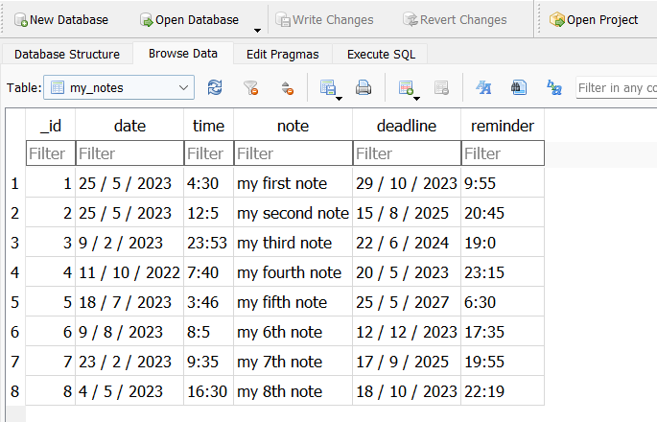

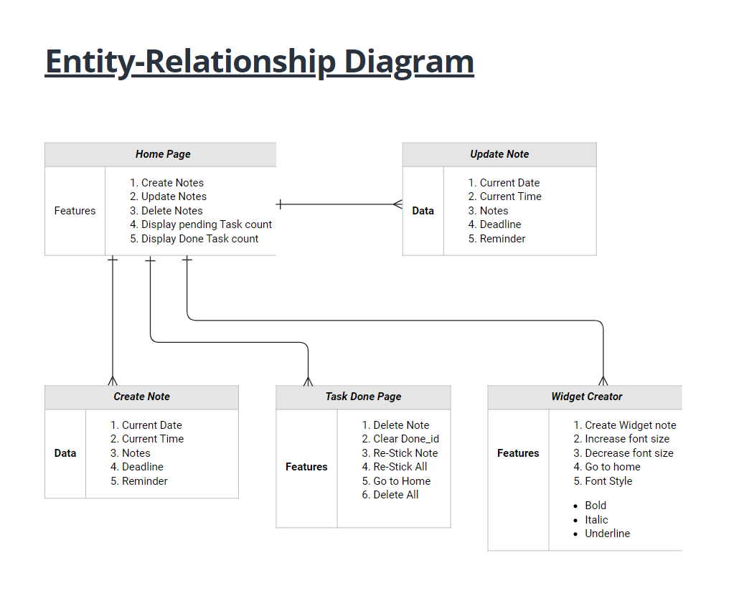

**Here goes Entity-Relationship Information and brief description for my Android Application**

In this project, There will be three separate activity. These are :

1. MainActivity
2. TaskDoneActivity
3. WidgetActivity

In MainActivity there we will have two buttons one to add notes and another to make an widget for that application. There will be a recycler view which will hold the created notes. To update or delete each of the created notes, we can just click on the task from recyclerview and then it will show you a popup Dialog menu for confirmation.

At the bottom right corner of the MainActivity page there will be a floating action button that will hold an icon to move between MainActivity and TaskDoneActivity where it will show a recyclerview with holding the tasks that’ve done by the user. And also there is a 3 dot menu you can delete all the notes at a time.

From Add task dialog, we can set there creation time, date, description, deadline and reminder. After completing that task, we can mark that note as done and after completing a task that marked note will be deleted from MainActivity and will be transferred to TaskDoneActivity. Also we have Date and Time Picker to set date and time from calender and clock using a button beside the EditText view.

We will also be able to add an widget for that application using the Create Widget button from MainActivity that will take user to another activity which will provide an access to create custom widget note. We can activate widget feature by picking the widget from our devices widget dropdown menu.

UI Design

*(Specific screens of the app for proper visualization)*

### Here goes Your Implementation Elias Ahahammed

Take Screenshot after creating minimum 6-8 pcs of notes

1. Homepage
2. Task done page
3. Widget Creator page
4. Widget on your phone screen
5. Update time pop up menu
6. Date picker
7. Time picker

That’s it.

After implementing these you can delete these previous ui designs below.

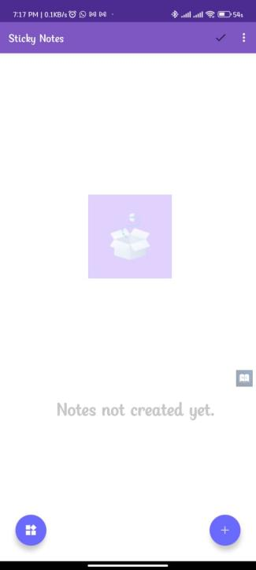 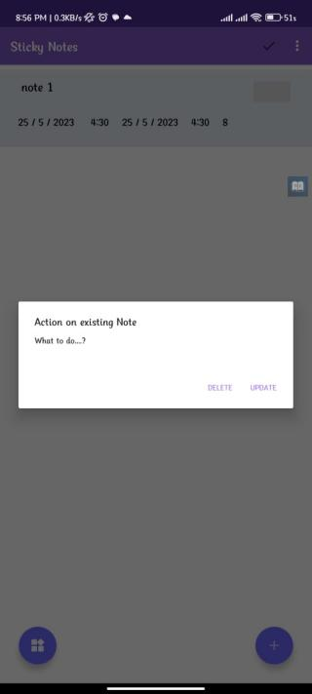 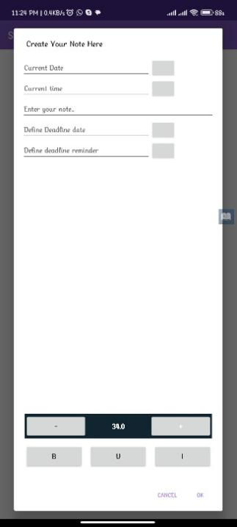

Empty MainActivity Update/Delete popup menu Add Task Dialog

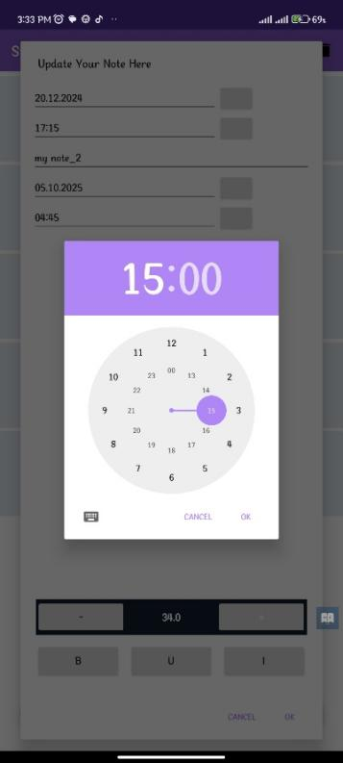 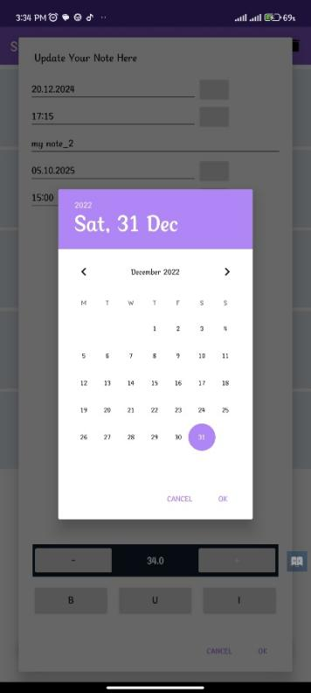 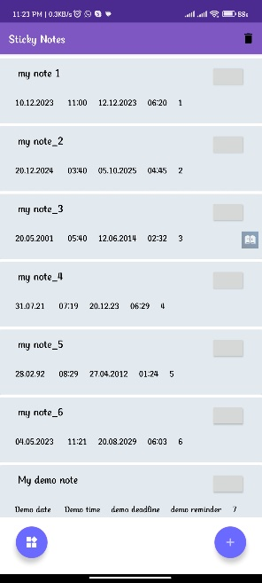

TimePicker Dialog DatePicker Dialog MainActivity After adding tasks

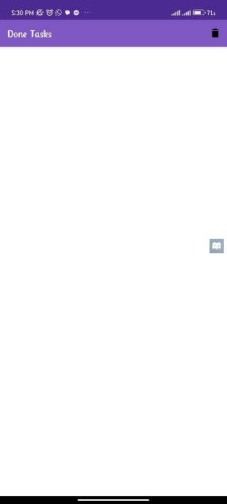 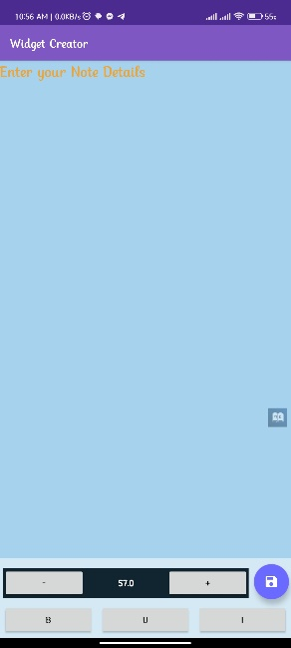 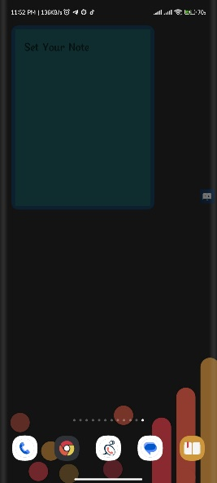

TaskDoneActivity WidgetCreatorActivity Widget in Device before set a note

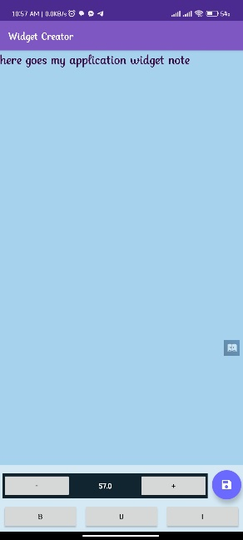 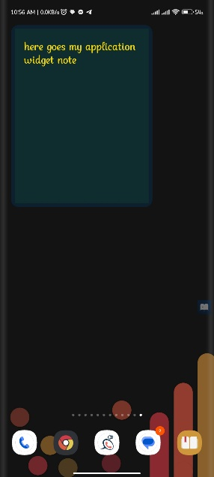

Setting a widget note After setting a widget note in Device window

Conclusion

In conclusion, building a sticky note application for Android involves a combination of user interface design, data management, and integration of features that enhance productivity and organization. Using modern tools like XML layout compose allows us to create a more efficient and maintainable codebase for building interactive and visually appealing sticky note application.

-------- o --------